CUSTOMER BEHAVIOR ANALYSIS

CONTENT

* Introduction
* Problem Definition
* Project Structure
* Dataset
* Languages
* Image
* Tables
* Chart

INTRODUCTION

Customer behavior analysis is the process of studying how customers interact with a business, including their purchasing patterns, preferences, and decision-making processes. The customer behaviour analysis will help to know about the customers’ habits, such as how much they post on social media, when they look at your products and what drives them to buy, is all encompassed by the term “customer behaviour” It describes **how**customers shop, from how often they make a purchase to how they respond to your marketing campaigns. Understanding this behaviour will help you make predictions about what comes next and adapt your strategies for – from product to sales and marketing – to better reflect your customer’s behaviour patterns. When you provide a customer experience that meets your customers’ needs, you’re more likely to drive sales and maximise your ROI.

This repository contains a comprehensive project to analyze the Customer behavior using machine learning techniques and various natural language processing techniques.

PROBLEM DEFINITION:

1. **Customer journey behavior** → Identify bottlenecks in the purchase process.
2. **Customer reviews & feedback** → Understand sentiment and satisfaction trends.
3. **Marketing effectiveness** → Measure the impact of engagement on conversion.
4. **Product & demographic analysis** → Identify high-performing products and customer segments.

PROJECT STRUCTURE:

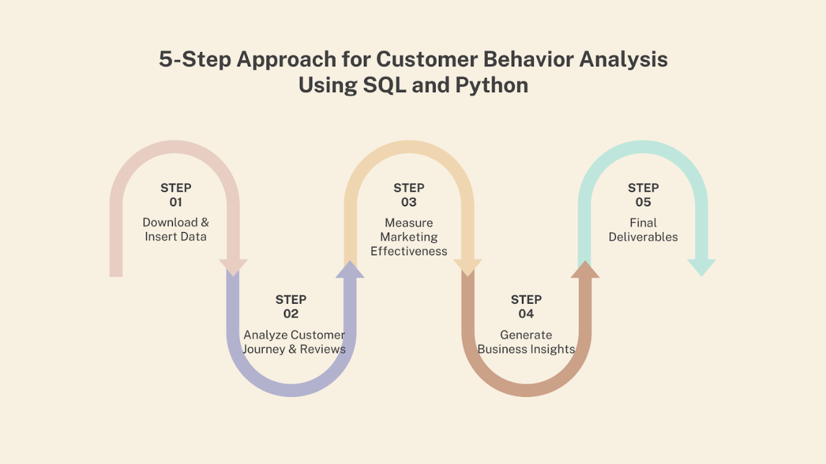

DATA SET:

1. customer_journey.csv -customer journey through different stages
2. customer_review.csv – detailed customer reviews on different product
3. customer.csv – customers detail
4. engagement_data.csv – factors which influencing customer engagement
5. geography.csv- customer and product based on location
6. product.csv – product description

LANGUAGES:

* Python
* SQL

TABLES:

AVERAGE DURATION PER STAGE (SQL):

|  |  |
| --- | --- |
| Stage | Average Duration |
| Checkout | 45.05 |
| Home page | 160.53703703703704 |
| Product Page | 182.76923076923077 |

IDENTIFY THE DROP OFF POINT (SQL)

|  |  |  |  |
| --- | --- | --- | --- |
| Journey ID | Customer ID | Stage | Visit Date |
| 1 | 64 | Checkout | 2024-06-10 |
| 2 | 94 | Checkout | 2025-07-09 |
| 4 | 33 | Checkout | 2025-05-28 |
| 11 | 23 | Checkout | 2023-08-22 |
| 21 | 58 | Checkout | 2024-03-07 |
| 24 | 77 | Checkout | 2025-06-25 |
| 32 | 67 | Checkout | 2023-09-04 |
| 37 | 38 | Checkout | 2024-06-18 |
| 47 | 30 | Checkout | 2024-02-18 |
| 52 | 15 | Checkout | 2025-08-07 |
| 54 | 9 | Checkout | 2024-11-19 |
| 55 | 1 | Checkout | 2024-03-17 |
| 71 | 40 | Checkout | 2023-07-13 |
| 93 | 43 | Checkout | 2023-08-22 |

BASED ON CUSTOMER RATING – TOP RATED PRODUCT(SQL)

|  |  |  |
| --- | --- | --- |
| **Product ID** | **Product Name** | **Average Rating** |
| 8 | Football Helmet | 5.0000 |
| 19 | Hockey Stick | 4.4000 |
| 18 | Volleyball | 4.0000 |
| 15 | Climbing Helmet | 4.0000 |
| 1 | Running Shoes | 4.0000 |

BASED ON CUSTOMER RATING – LEAST RATED PRODUCT(SQL)

|  |  |  |
| --- | --- | --- |
| **Product ID** | **Product Name** | **Average Rating** |
| 7 | Basketball | 2.6667 |
| 12 | Ice Skates | 3.0000 |
| 4 | Dumbbells | 3.0000 |
| 16 | Kayak | 3.4000 |
| 9 | Baseball Clove | 3.4000 |

OVERALL CUSTOMER RATING BASED ON PRODUCT: (SQL)

|  |  |  |  |  |  |  |
| --- | --- | --- | --- | --- | --- | --- |
| Product ID | Product  Name | Total  Reviews | Average  Rating | Minimum  Rating | Maximum Rating | Price |
| 8 | Football Helmet | 3 | 5.0000 | 5 | 5 | 327.36 |
| 19 | Hockey Stick | 5 | 4.4000 | 4 | 5 | 225.12 |
| 18 | Running Shoes | 3 | 4.0000 | 3 | 5 | 262.32 |
| 15 | Soccer Ball | 6 | 4.0000 | 2 | 5 | 410.17 |
| 1 | Ski Boots | 4 | 4.0000 | 3 | 5 | 472.32 |
| 11 | Climbing Rope | 6 | 4.0000 | 3 | 5 | 26.21 |
| 20 | Volleyball | 2 | 4.0000 | 4 | 4 | 196.68 |
| 5 | Boxing Gloves | 3 | 4.0000 | 4 | 4 | 44.75 |
| 17 | Surfboard | 9 | 3.8889 | 2 | 5 | 81.59 |
| 6 | Tennis Racket | 7 | 3.8571 | 1 | 5 | 173.83 |
| 3 | Yoga Mat | 7 | 3.7143 | 1 | 5 | 37.56 |
| 13 | Swim Goggles | 9 | 3.6667 | 3 | 4 | 259.4 |
| 2 | Fitness Tracker | 7 | 3.5714 | 2 | 5 | 223.75 |
| 10 | Golf Clubs | 4 | 3.5000 | 2 | 5 | 340.2 |
| 9 | Baseball Glove | 5 | 3.4000 | 3 | 4 | 41.26 |
| 16 | Kayak | 10 | 3.4000 | 2 | 4 | 275.43 |
| 4 | Dumbbells | 5 | 3.0000 | 1 | 5 | 145.97 |
| 12 | Ice Skates | 2 | 3.0000 | 3 | 3 | 36.07 |
| 7 | Basketball | 3 | 2.6667 | 2 | 3 | 42.8 |

KEY COMPLAINTS(P):

|  |  |  |  |
| --- | --- | --- | --- |
| **Product ID** | **Product Name** | **Review Text** | **Rating** |
| 13 | Swim Goggle | Average experience, nothing special. | 3 |
| 17 | Surfboard | Average experience, nothing special. | 2 |
| 16 | Kayak | Average experience, nothing special. | 2 |
| 10 | Golf Clubs | Disappointed with the performance. | 2 |
| 2 | Fitness Tracker | Product did not meet my expectations. | 2 |
| 7 | Basketball | The product is okay, but the instruction | 2 |
| 15 | Climbing Rope | The product arrived late. | 2 |
| 3 | Yoga Mat | Not worth the money. | 1 |
| 4 | Dumbbells | The product stopped working after a month. | 1 |
| 6 | Tennis Racket | I had a bad experience with this product.1.0 | 1 |

 PATTERN BETWEEN NEGATIVE REVIEW AND PRODUCT PERFORMANCE

|  |  |  |  |  |  |
| --- | --- | --- | --- | --- | --- |
| **Rating** | **Product ID** | **Review Text** | Clicks | View | Purchase |
| 1 | 3 | Not worth the money. | 0 | 2 | 0 |
|  | 4 | The product stopped working after a month. | 3 | 2 | 0 |
|  | 6 | I had a bad experience with this product. | 1 | 2 | 0 |
| 2 | 2 | Product did not meet my expectations. | 2 | 3 | 1 |
|  | 7 | The product is okay, but the instructions were unclear. | 0 | 0 | 0 |
|  | 10 | Disappointed with the performance. | 2 | 5 | 0 |
|  | 15 | The product arrived late. | 1 | 3 | 2 |
|  | 16 | Average experience, nothing special. | 1 | 3 | 1 |
| 2.5 | 17 | Average experience, nothing special. | 0 | 2 | 2 |
| 3.0 | 13 | Average experience, nothing special. | 1 | 2 | 0 |

BEST PERFORMING PRODUCT PER REGION: (P)

|  |  |  |  |
| --- | --- | --- | --- |
| Country | City | Product ID | Purchase Count |
| Austria | Vienna | 1.0 | 3 |
| Belgium | Brussels | 2.0 | 2 |
| France | Paris | 4.0 | 1 |
| Germany | Berlin | 2.0 | 1 |
| Italy | Rome | 10.0 | 3 |
| Netherlands | Amsterdam | 15.0 | 2 |
| Spain | Madrid | 8.0 | 3 |
| Sweden | Stockholm | 12.0 | 1 |
| Switzerland | Zurich | 18.0 | 3 |
| UK | London | 19.0 | 2 |

SENTIMENT ANALYSIS

COMMON ACTION LEADING TO SUCCESSFUL CONVERSION (SQL)

|  |  |  |  |
| --- | --- | --- | --- |
| **Content Type** | **Total Likes** | **Total views & click** | **Purchase-count** |
| Newsletter | 1708 | 28755 | 11 |
| Video | 1552 | 19126 | 11 |
| Social media | 897 | 20423 | 7 |
| Blog | 290 | 22358 | 9 |

CONVERSION RATES BY CONTENT TYPE:

|  |  |  |  |
| --- | --- | --- | --- |
| **Content Type** | **Purchase Count** | **Count** | **Conversion Rate (%)** |
| Newsletter | 11 | 17 | 64.705882 |
| Video | 11 | 31 | 35.483871 |
| Blog | 9 | 28 | 32.142857 |
| Social media | 7 | 24 | 29.166667 |

CHARTS:

